ABOUT US PAGE
- Use this updated wireframe as a guide to enhance the layout of the about.html page.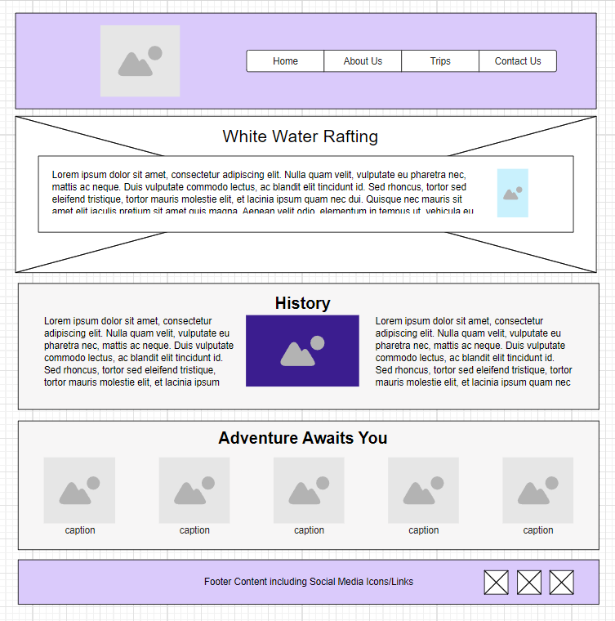
- Open the about.html file and the rafting.css files for editing.
- Continue to make updates to the page.
- Use CSS Grid in the header to create the horizontal layout between the logo and the navigation bar.
- Use CSS Flex to create the horizontal layout in the nav
- Style the header, img, and nav as needed to create a well designed header that will also be used on the other pages of this rafting site providing a consistent look and feel across the site.
- Layout the History section elements as shown in the wireframe layout.
- Style the Adventures section with five images to span the section horizontally using a CSS layout method. Use figure elements to contain the img elements and use figcaption captions for each figure image, labeling them with the trip adventure name or the water rapid name(the images you will use include rafting20_600, rafting4_600, rafting29_600, rafting22_600, rafting47_600 and I’ve added in the wwr image folder), e.g., "Los Dientes del Diablo", "Big Mallard", "Half Day Adventure", etc.
- Style the footer so that the three social images fit in the space and are arranged horizontally and to the right as pictured in the wireframe.

